

**Predicting the Fuel Efficiency of 1970s Vintage Cars**

**05 May 2021**

**Rice University**

**Data Analytics**

Prepared by

**Alex Jones**

**Jessica Pardo**

**Dana Woodruff**

1. **INTRODUCTION**

As 1970 dawned the world’s cars averaged 149 horsepower and 17 miles per gallon… gas was cheap and the roar of the engines drowned out Elvis Presley and Creedence Clearwater Revival on the radio.

October 1973 brought the Yom-Kippur War. Early in the war, the U.S supplied Israel with arms, angering the Arab delegation of OPEC, which responded with an embargo of oil sales to the U.S. and other industrial centers. And so began the decade’s first oil crisis that sent oil prices skyrocketing upwards and auto manufacturers scrambled to offer more fuel efficient cars.

Hop in and take a journey throughout the 1970s with us as we first visualize oil prices and fuel efficiency throughout the decade. Then we’ll pop the hood and see what changed to bring about an 88% improvement in fuel efficiency by 1982.

Our next stop is with Machine Learning models. As you’re flipping through the latest digital copy of Hemmings, debating between a 1970 Pontiac GTO “The Judge” or an iconic 1975 Rolls Royce Silver Shadow, the model will predict the gas mileage you’ll experience with your “new” vintage beauty.

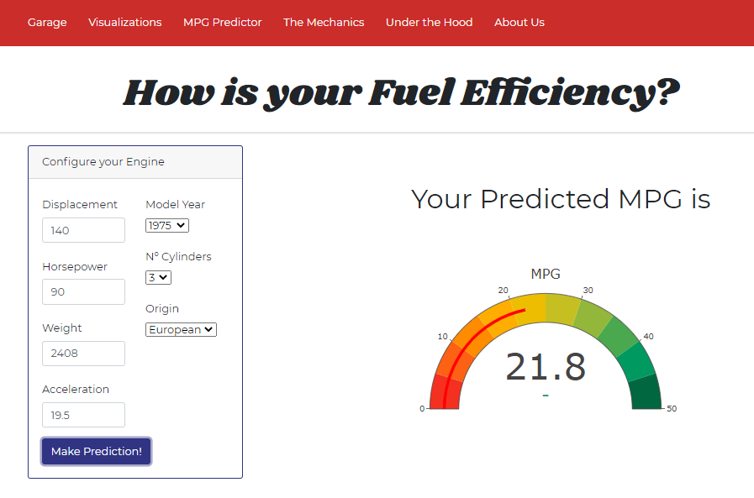

1. **DATA**

Data is gratiously sourced from Kaggle and the University of California, Irvine.

The original data .csv file is relatively clean. It is a small dataset, approximately 400 records, and Excel was used for the minimal cleaning required. Six null values in "horsepower" field were replaced with the manufacturers' specified values for Tableau visualizations. The six values were replaced with median values for the machine learning models.

Make and model values were separated into independent fields utilizing Excel's native "text to columns" functionality, for better Tableau visualization prospects. "Make" was listed as unique values to spot misspellings which were then corrected and was capitalized for better tableau visualization. the clean .csv was read into Tableau.

Data fields include make, model, model year, horsepower, engine displacement, engine cylinders, acceleration, fuel efficiency, and vehicle weight.

A second .csv was imported that provides inflation adjusted world oil prices for each of the twelve years.

1. **TABLEAU VISUALIZATIONS**

Ten worksheets each have a visualization. The visualizations are brought together on six dashboards which are then presented as a story. The main filter serves to retrieve data for each year unless the data is presented as a time series. The story captions summarize each dashboard and guide the user through the dashboards.

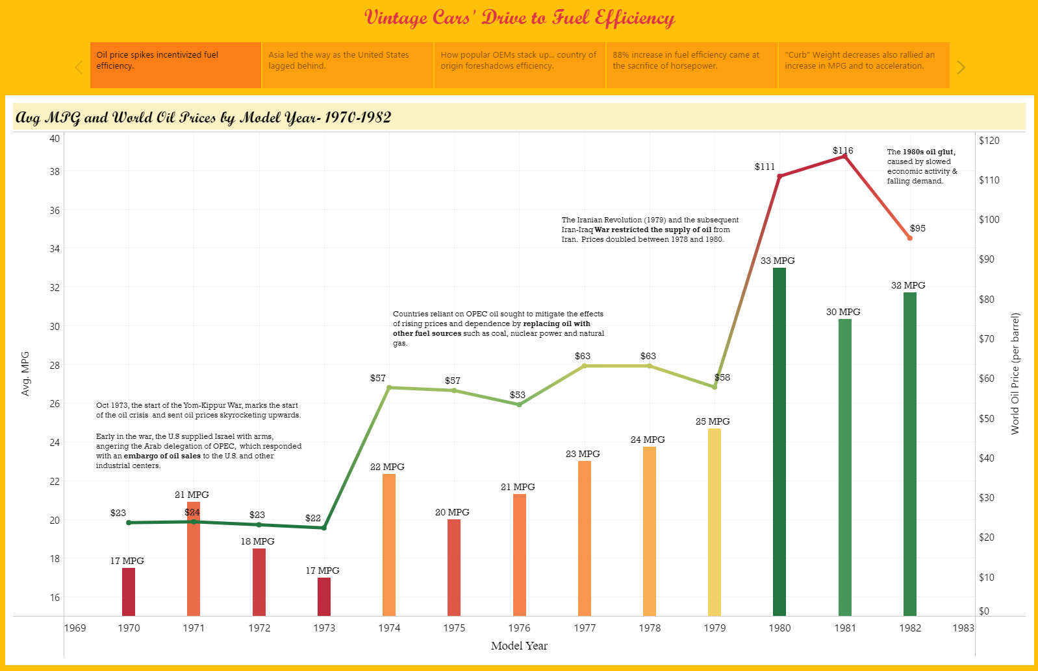

Next the user explores how country of origin influences fuel efficiency. Asia is the frontrunner for the time period with the United States and England trailing the pack.

The user can select which year(s) to view and tooltips provides the average metrics for each field by country.

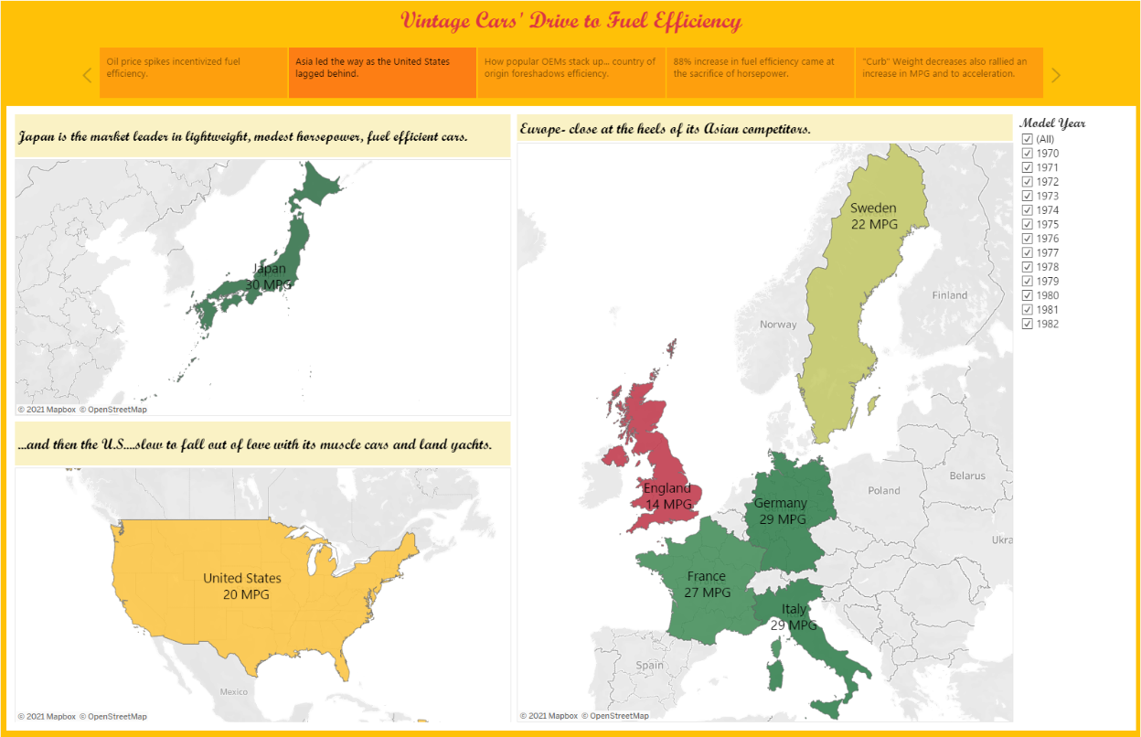

Individual make and fuel efficiency are examined in the third dashboard. The dashboard is generous with labels to provide an easy view of data and, again, tooltips are utilized to provide a wider data view. A summary by country also functions as a legend in the lower right corner.

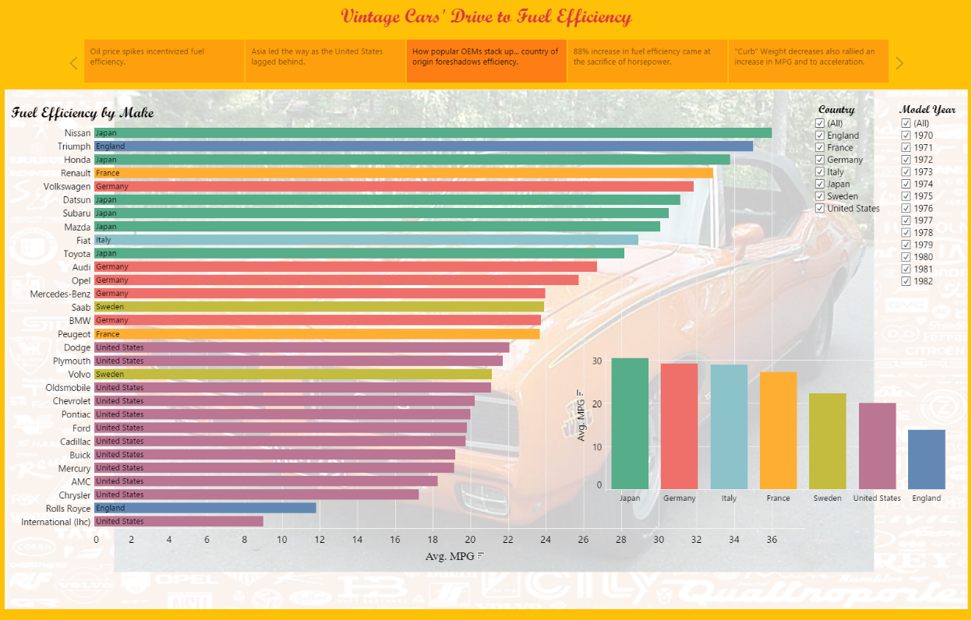

The user then explicity views the 46% reduction in horsepower and an 88% increase in fuel efficiency between 1970 and 1982.

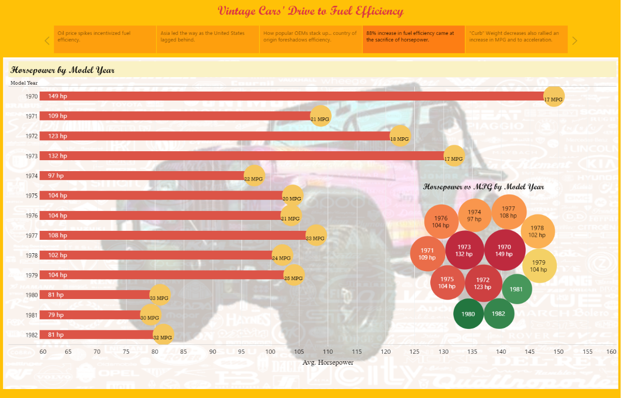

Engine metrics roar to life in the final two dashboards. A 28% decrease in weight, a 45% decrease in horsepower, and a 55% decrease in engine displacement contributed to the 88% MPG improvement and a 31% improvement in acceleration.

Blended and dual axis scales allowed the three independent metrics to show with a shared x-axis.

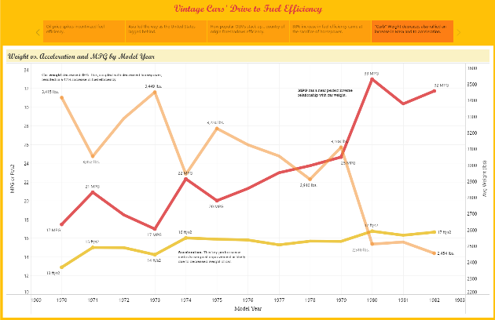 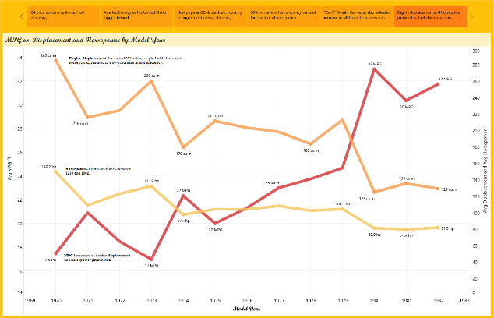

1. **MACHINE LEARNING**

DATA

The dataset is imported into Jupyter Notebook and read into a pandas dataframe. Data is examined for null values, and pandas “Describe” is used to understand the data prior to machine learning model implementation.

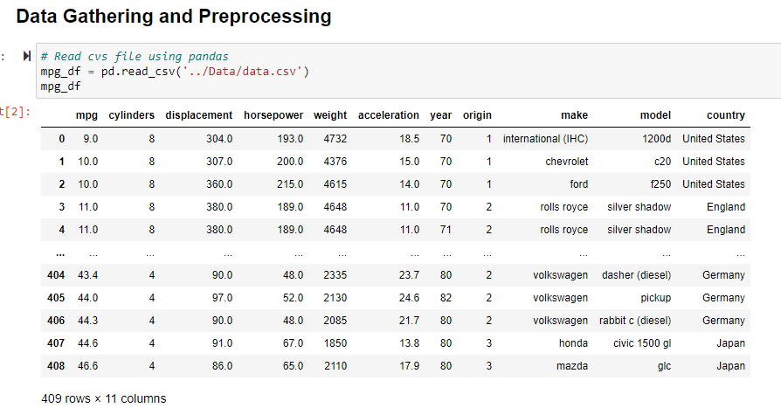

Examination for correlations is made both as a dataframe and a visualization.

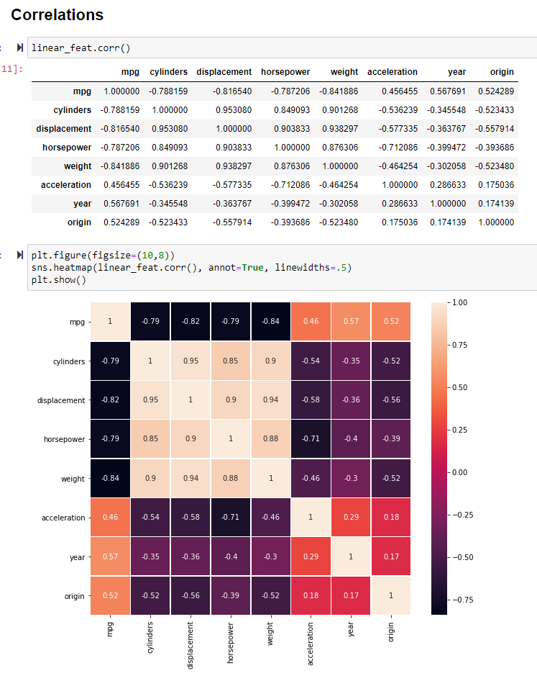

Pair plots, another correlation tool, clearly demonstrates that "cylinders" and "origin" fields do not shows a normal distribution as they represent a specific value and can be considered categorical values.

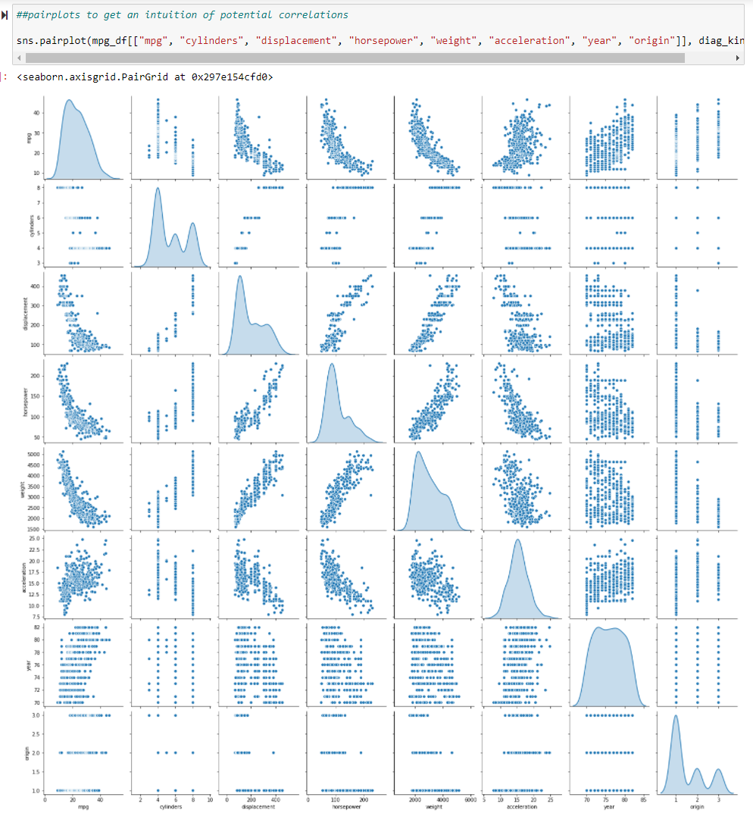

TRAINING THE MODEL

Training of the data begins with dropping columns determined to be categorical in nature. 30% of the data was used as a test set.

MODELS

Linear models explored include Linear, Ridge, Lasso, and ElasticNet.

Linear model:

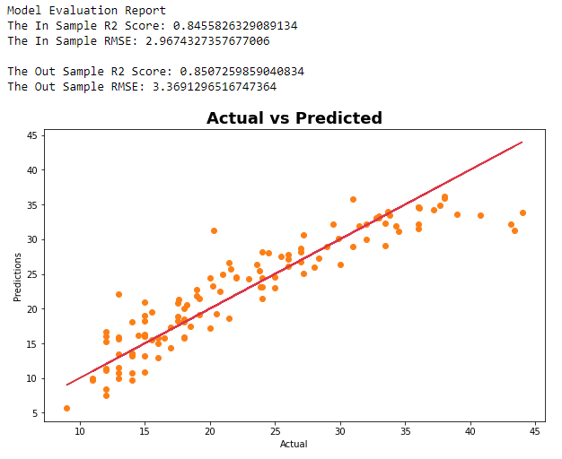

Elastic Net model:

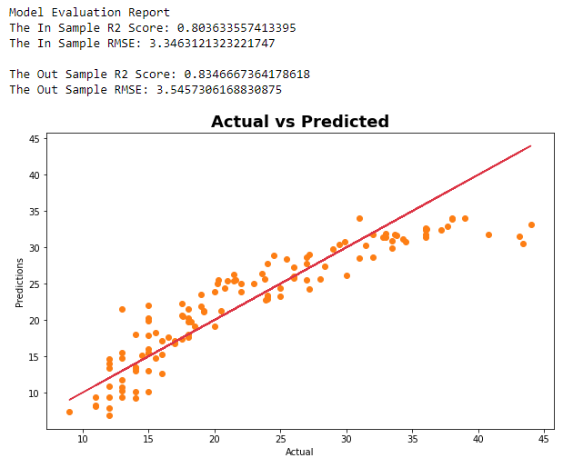

Random Forest models explored are DecisionTree, Random Forest, AdaBoost, and Gradient Boost.

Random Forest:

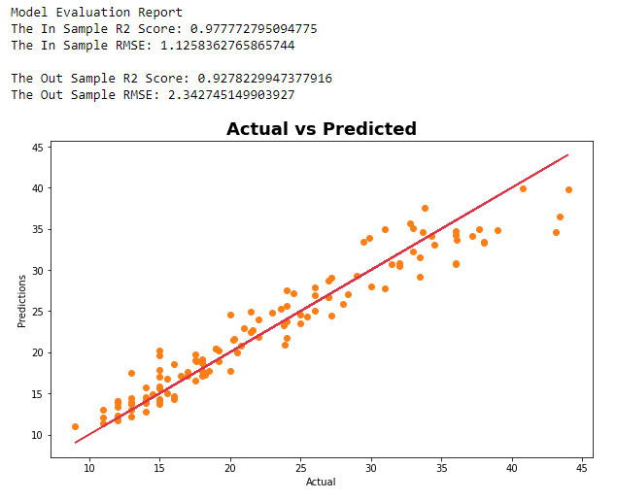

Model results were viewed as a dataframe for easy comparison and selection.

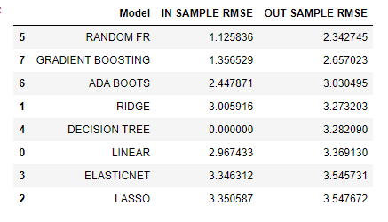

The Random Forest model was choosen because it has the lowest RMSE and doesn't overfit the in sample data.

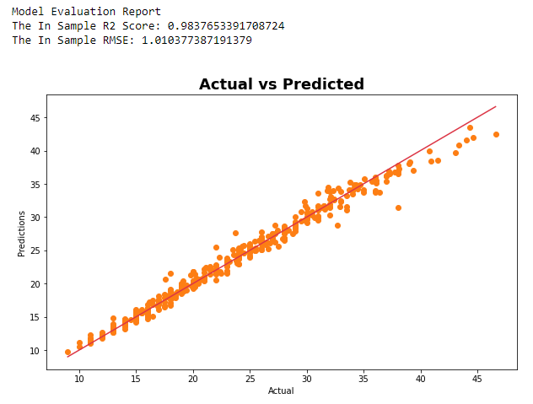

1. **PREDICTING THE PAIN at the PUMP**

The pickled model is then used to predict a car’s fuel efficiency based on characteristics selected by the user that include model year, engine displacement, horsepower, and vehicle weight.

1. **DEPLOYMENT**

The project is packaged as a full stack web deployment on Heroku.  
  
The "Garage" page introduces the user to the project. it includes an interactive slideshow with twelve car images from the time period. A navigation bar allows the user to visit several different pages:

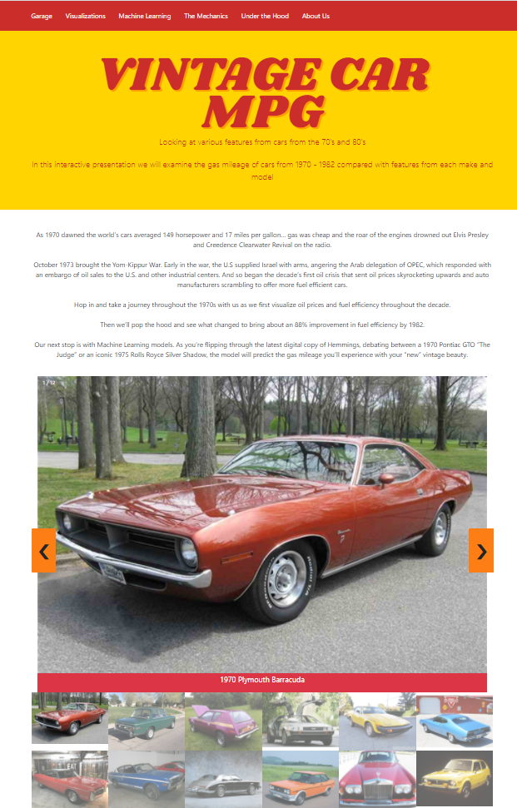

* Visualizations - This is the Tableau storyboard
* MPG Predictor - This is the predictive activity
* The Mechanics - This is the explanation of the Machine Learning behind the prediction.

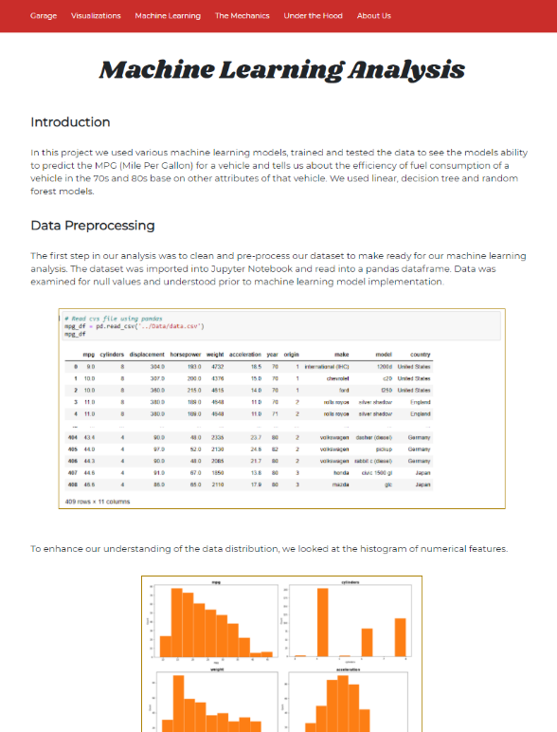

* Under the Hood - This is the dataset. This can be filtered by one to three metrics.

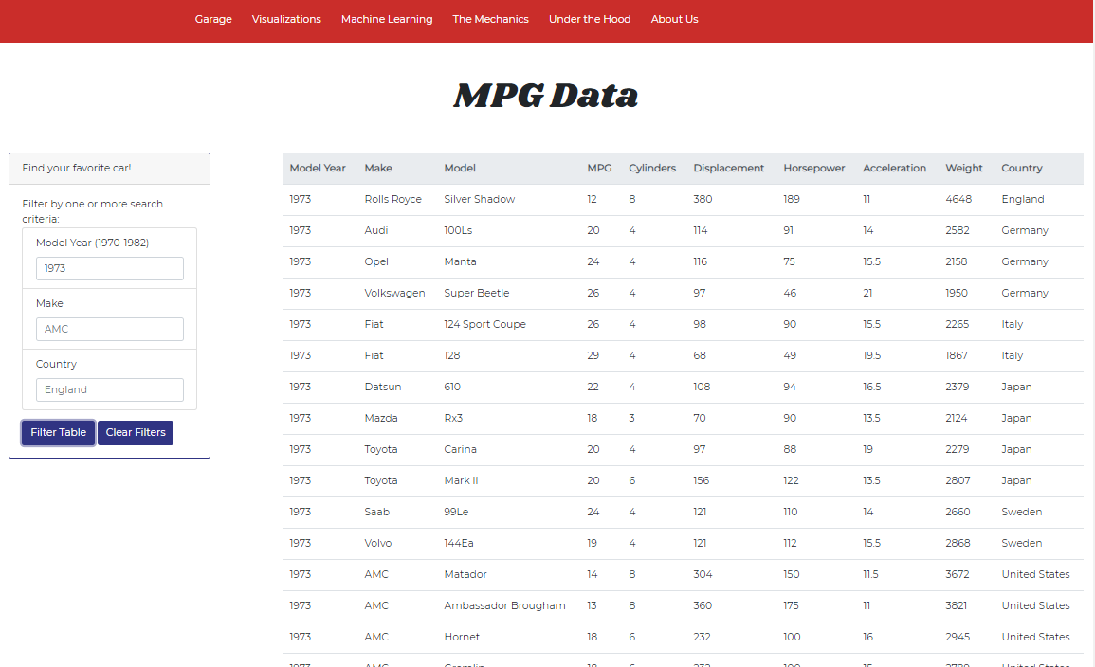

* About Us - This is the team that crafted the project.

Tableau is deployed in tableau Public at: <https://public.tableau.com/profile/dana.woodruff#!/vizhome/Vintage-Car-MPG/VintageCars?publish=yes>

The website is deployed at: {TBD}

Project materials are held in GitHub at: <https://github.com/jessicapardo/Vintage-Cars-MPG>

…with forks at:

<https://github.com/danawoodruff/Vintage-Cars-MPG>

<https://github.com/BaudOptics/Vintage-Cars-MPG>

1. **REFERENCES**

Carnegie Mellon University. *Auto MPG Data Set*. 1983. http://archive.ics.uci.edu/ml/datasets/Auto+MPG. 21 April 2021.

Hallman, Carly. *Gas Prices Through History*. 2016. https://www.titlemax.com/discovery-center/planes-trains-and-automobiles/average-gas-prices-through-history/. 23 April 2021.

History.com Editors. *Energy Crisis (1970s)*. 30 August 2010. https://www.history.com/topics/1970s/energy-crisis. 22 April 2021.

Macrotrends. *Crude Oil Prices - 70 Year Historical Chart*. 2021. https://www.macrotrends.net/1369/crude-oil-price-history-chart. 22 April 2021.

Wikipedia. *1970s energy crisis*. 15 April 2021. https://en.wikipedia.org/wiki/1970s_energy_crisis. 23 April 2021.